**Telerik RadCartesianChart**

# Xaml z RatingDataVieweru:

<telerik:RadCartesianChart x:Name="chart" Grid.Row="0" Grid.RowSpan="2" Grid.Column="0">

<telerik:RadCartesianChart.TrackBallLineStyle>

<Style TargetType="Polyline">

<Setter Property="Stroke" Value="DeepSkyBlue"/>

<Setter Property="StrokeThickness" Value="1.2"/>

<Setter Property="ToolTipService.ShowDuration" Value="100000"/>

<Setter Property="ToolTip">

<Setter.Value>

<ToolTip Content="{Binding Path=TooltipInfo}"

Template="{StaticResource triangleToolTipTemplate}" Foreground="Black"/>

</Setter.Value>

</Setter>

</Style>

</telerik:RadCartesianChart.TrackBallLineStyle>

<telerik:RadCartesianChart.Grid>

<telerik:CartesianChartGrid MajorLinesVisibility="Y" MajorXLinesRenderMode="All"/>

</telerik:RadCartesianChart.Grid>

<telerik:RadCartesianChart.Annotations>

<telerik:CartesianGridLineAnnotation/>

<telerik:CartesianPlotBandAnnotation From="0" To="300" Axis="{Binding ElementName=verticalAxis}" Background="DeepSkyBlue" Fill="Red" Stroke="Gold" StrokeThickness="5"/>

<telerik:CartesianMarkedZoneAnnotation HorizontalFrom="08:00:00" HorizontalTo="20:00:00"

VerticalFrom="0" VerticalTo="300"/>

</telerik:RadCartesianChart.Annotations>

<telerik:RadCartesianChart.Behaviors>

<telerik:ChartTrackBallBehavior ShowIntersectionPoints="False" SnapMode="AllClosePoints" TrackInfoUpdated="ChartTrackBallBehavior_OnTrackInfoUpdated">

<i:Interaction.Triggers>

<i:EventTrigger EventName="TrackInfoUpdated">

<Behaviors:EventCommandBehavior Command="{Binding Path=DataContext.TrackInfoUpdatedCommand, ElementName=chart, UpdateSourceTrigger=PropertyChanged}"/>

</i:EventTrigger>

</i:Interaction.Triggers>

</telerik:ChartTrackBallBehavior>

<telerik:ChartPanAndZoomBehavior DragMode="Pan" PanMode="Both" ZoomMode="Both"/>

<Behaviors:AnalysesBehavior AnalysesPanel="{Binding Path=AnalysesButtonPanel}" MinDateTime="{Binding Path=MinAxisDateTime}" MaxDateTime="{Binding Path=MaxAxisDateTime}"/>

</telerik:RadCartesianChart.Behaviors>

<telerik:RadCartesianChart.SeriesProvider>

<telerik:ChartSeriesProvider Source="{Binding Series}">

<telerik:ChartSeriesProvider.SeriesDescriptors>

<telerik:CategoricalSeriesDescriptor ItemsSourcePath="ChannelValues" ValuePath="Rating" CategoryPath="DateTime">

<telerik:CategoricalSeriesDescriptor.Style>

<Style TargetType="telerik:LineSeries">

<Setter Property="Visibility" Value="{Binding Visibility}"></Setter>

<Setter Property="Stroke" Value="{Binding Brush}"/>

<Setter Property="StrokeThickness" Value="1"/>

<Setter Property="TrackBallInfoTemplate" Value="{StaticResource trackBallInfoTemplate}"/>

<Setter Property="TrackBallTemplate" Value="{StaticResource trackBallTemplate}"/>

<!--<Setter Property="RenderOptions">

<Setter.Value>

-->

<!--<telerik:Direct2DRenderOptions AntialiasMode="Aliased" />-->

<!--<telerik:BitmapRenderOptions/>-->

<!--

<telerik:XamlRenderOptions EdgeMode="Aliased" GeometryType="StreamGeometry" />

</Setter.Value>

</Setter>-->

<Setter Property="LegendSettings">

<Setter.Value>

<telerik:SeriesLegendSettings Title="{Binding ChannelName}"/>

</Setter.Value>

</Setter>

</Style>

</telerik:CategoricalSeriesDescriptor.Style>

</telerik:CategoricalSeriesDescriptor>

</telerik:ChartSeriesProvider.SeriesDescriptors>

</telerik:ChartSeriesProvider>

</telerik:RadCartesianChart.SeriesProvider>

<telerik:RadCartesianChart.VerticalAxis>

<telerik:LinearAxis x:Name="verticalAxis"/>

</telerik:RadCartesianChart.VerticalAxis>

<telerik:RadCartesianChart.HorizontalAxis>

<telerik:CategoricalAxis x:Name="CategoricalAxis"

MajorTickInterval="50"

GapLength="0.5"

LabelInterval="2"

LabelFitMode="MultiLine"

LabelTemplate="{StaticResource AxisXLabelTemplate}"/>

</telerik:RadCartesianChart.HorizontalAxis>

</telerik:RadCartesianChart>

# Poznamky:

Postup zde:

<https://docs.telerik.com/devtools/wpf/controls/radchartview/getting-started/introduction>

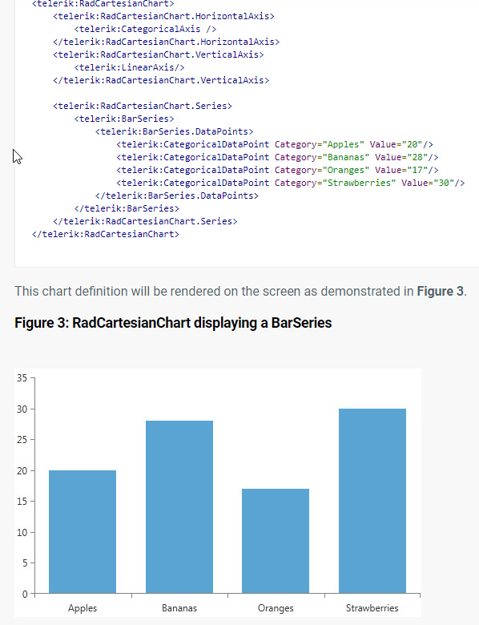

# Nastaveni casove osy – rozestup labelu

5. minutovy rozestup: MajorStepUnit="Minute" MajorStep="5"



# Otoceni vertical vs horizontal chart

To je definovano tim, co dam v xamlu do horizontal a vertical axis:

Horizontalni graf:

<telerik:RadCartesianChart.HorizontalAxis>

<telerik:DateTimeContinuousAxis />

</telerik:RadCartesianChart.HorizontalAxis>

<telerik:RadCartesianChart.VerticalAxis>

<telerik:LinearAxis />

</telerik:RadCartesianChart.VerticalAxis>

